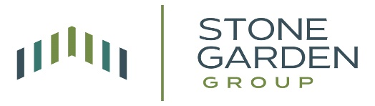

Stone Garden Group
Investment Committee Memo
EnCap Energy Capital Fund XII

Contents
Overview 3
1) Description 4
2) Edge/Competitive Advantage: (9 out of 10) 11
3) Pacing: B+ (8 out of 10) 12
4) Quality: (9 out of 10) 15
5) Risk/Reward: (10 out of 10) 16
6) WHY: (10 out of 10) 18

Overview
Investment: EnCap Energy Capital Fund XII (“Fund XII”)
Timing: Notify and begin docs by 9/13/24, close and fund 9/30/24 or sooner
Recommended size: $37.5mm (1.7% of $2.2b). $11.6mm due at close, with an estimated $3.6mm being distributed in Q4 2024.
Risk/Reward: 15x upside vs. downside
Executive Summary:
EnCap Energy Capital Fund XII is targeting $4 billion (with a hard cap of $4.4 billion) for investments in upstream oil and gas companies in North America. EnCap has a strong track record, with 9 out of 11 previous upstream funds performing well, generating an average IRR of 21.4% and 1.7x MOIC. The current fund (Fund XII) has already deployed capital into eight portfolio companies, focusing on key basins such as Permian, Delaware, Midland, Bakken, and Eagle Ford.
The fund's strategy involves backing experienced management teams to acquire and develop undervalued assets, then selling to corporates or strategics. EnCap's competitive advantage stems from its long-standing industry relationships, technical expertise, and ability to adapt to changing market dynamics. The fund charges a management fee of 1.5% on invested capital during the investment period, 20% carried interest with an 8% preferred return, and anticipates a 4.7% GP commitment.
The investment thesis is based on continued global energy demand, underinvestment in traditional oil and gas, attractive valuations, and tight supply conditions. The Stone Garden Group projects a base case net IRR of 18.4% and 3.9x MOIC, with a downside case of 1.1% IRR and 1.09x MOIC. Key risks include energy price declines, execution risk, and potential regulatory changes. The recommended investment size for Stone Garden Group is $37.5 million (1.7% of the $2.2 billion target), with an estimated $11.6 million due at close and a projected distribution of $3.6 million in Q4 2024.

Description
  - History of firm/company (provided by sponsor, edited for space):
    - Founded in 1988, EnCap is a leading provider of growth equity to the independent sector of the energy industry. Over its 34-year history in energy investing, the Firm has generated strong returns by applying a disciplined philosophy that balances capital preservation and value creation.
      - EnCap’s day-to-day operations are led by two Managing Partners, Jason M. DeLorenzo and Douglas E. Swanson, Jr., with support from Partners Kyle M. Kafka and Brad A. Thielemann. Charles W. Bauer is a Partner and leads EnCap’s Investor Relations efforts.
      - The Firm’s four Founders, David B. Miller, Gary R. Petersen, D. Martin Phillips, and Robert L. Zorich continue to be active in an advisory role and maintain an ownership position in EnCap. The EnCap Principals (Partners + Founders) have an average of 33 years of industry-related experience including an average 25-year tenure at EnCap.
      - In addition to the EnCap Principals, EnCap has a bench of qualified investment professionals and support staff, including 10 professionals on the upstream Investment Staff, three professionals on EnCap’s in-house Technical Team, two professionals in Investor Relations, a professional who spearheads ESG efforts, and a 21-person fund administration staff, which includes 11 certified public accountants.
    - Since its inception, EnCap has managed approximately $39.0 billion of capital commitments across twenty-two institutional funds. The Firm’s first six funds, raised between 1988 and 1993, consisted of three reserve acquisition funds and three mezzanine debt funds. In 1994, EnCap transitioned its model to providing growth equity primarily to the upstream industry with the belief that this strategy offered a more attractive risk/return proposition and better alignment between EnCap and its portfolio company management teams. Since that time, the Firm has raised eleven upstream growth-oriented equity funds totaling approximately $28.5 billion† in capital commitments before the formulation of Fund XII.
    - In 2008, EnCap expanded its investment platform to include funds focused on investments in the midstream sector of the energy industry. As an integral part of this expansion, the Firm partnered with Flatrock Energy Advisors, LLC. whose principals have extensive midstream expertise. Since 2008, EnCap Flatrock Midstream has raised approximately $9.0 billion of capital commitments across four growth equity funds dedicated to this strategy.
    - In 2019, in response to the expansion of economic investment opportunities in the energy transition space, the Firm recognized a need to have a focused effort on this opportunity. As a result, EnCap retained a highly regarded industry team to manage a newly formed EnCap Energy Transition Fund platform. EETF focuses on providing growth equity to start-ups or early-stage companies investing in opportunities created by the global transition to a lower-carbon energy system. EnCap’s first EETF fund closed in April 2021 with approximately $1.2 billion of capital commitments.
    - As of September 30, 2022, the EnCap Upstream Funds had invested approximately $26.3 billion in 205 different companies. A total of 171 investments representing approximately $13.9 billion of invested capital have been realized or substantially realized, resulting in approximately $25.1 billion of value (including realized proceeds and unrealized value). These realized and substantially realized investments have generated a 1.8x gross ROI and 26.8% gross IRR and a 1.5x net ROI and 18.7% net IRR.
    - EnCap believes its track record reflects the Firm’s successful and consistent ability to adapt to changing market dynamics and allocate capital to economically attractive investment opportunities. Furthermore, EnCap believes its demonstrated ability to attract high quality management teams, and the resulting success achieved with these teams validates the strength and continued viability of the Firm’s investment model.

  - Performance History (9 out of 10):
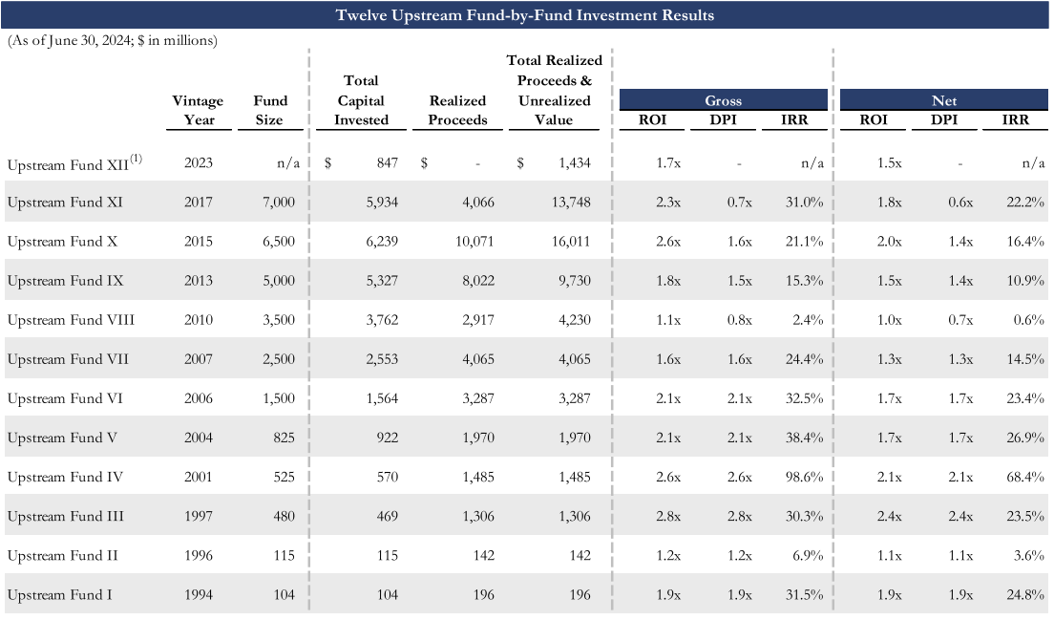
    - EnCap Upstream has had two bad funds out of eleven (82% hit rate) and neither lost money.
      - The average IRR has been 21.4% through a variety of energy market environments since 1994. If you remove the two lagging funds (II and VIII) and the outsized return from fund IV (68.4% IRR), the average IRR has been 20.3%.
      - The average multiple of invested capital (MOIC) has been 1.7x going back to Fund I. If you take out the same three outliers as above, the average is 1.8x.
    - Versus the peer group:
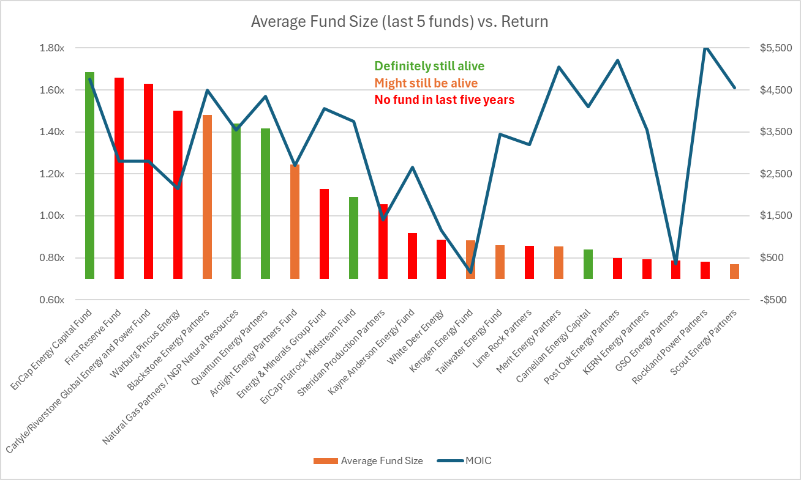
      - EnCap Upstream has had the largest average fund size (average over the last five funds) and the highest return (MOIC) for their large cap peer group.
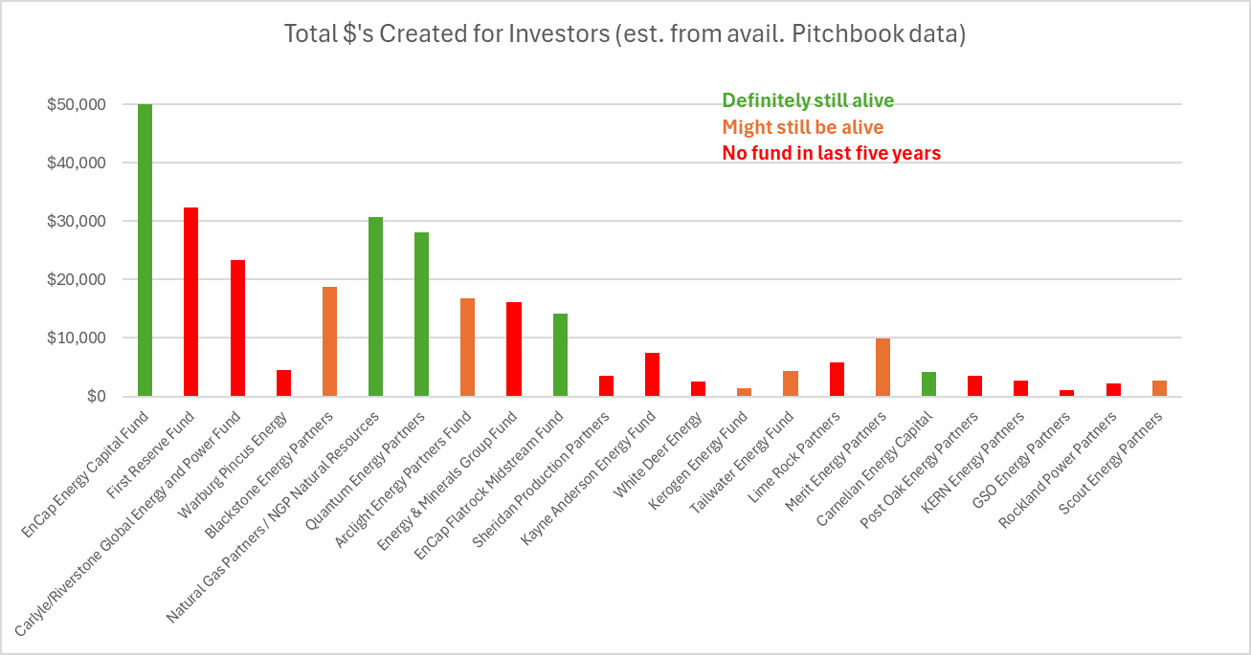
      - And they’ve been doing it for a long time, which has resulted in significant value created for investors.
  - Capacity: Reserving up to $50mm for Stone Garden Group, but approaching $4b “hard cap”.
  - Target size (vs. last): EnCap is targeting $4b in commitments, with the predecessor fund at $7b in commitments.
  - Source of investment: EnCap was introduced to Zach Matula by EnCap Partner Marty Phillips from the Memorial Hermann board, Sam Levens had a previous relationship with the firm.
  - Stated return target/underwriting: Fund XII is targeting a net IRR of 20% and MOIC of 1.75x. It is important to note that they’ve hit this about half the time.
  - Investment minimum: $10mm
  - Current portfolio:
    - Double Eagle IV:
      - Double Eagle IV has made significant progress in the Permian Basin, aggregating over 50,000 net acres through numerous acquisitions and trades. The company is actively developing its assets, running a 5-rig program that has driven production to exceed 40 Mboe/d in Q2 2024. This aggressive development strategy has yielded impressive results, with the investment now valued at $619,756,000, representing a 2.26x return on investment (ROI). Double Eagle IV continues to evaluate acquisition opportunities in the Permian Basin, leveraging the team's prior experience and competitive advantages in the region.
    - Grayson Mill III:
      - Grayson Mill III has undergone a transformative period since its acquisition of Ovintiv's Bakken assets for $825 million in Q2 2023. These assets, comprising approximately 44,000 net acres and producing around 34 MBoe/d net (80% liquids), have proven to be a valuable addition to the portfolio. The company has successfully operated and developed the assets, bringing operations in-house and initiating a 1-rig program along with refrac operations. In June, EnCap announced that Grayson Mill has agreed to be sold to Devon Energy for $1.35 Billion in cash and stock. The investment is currently valued at $447,181,000, boasting an impressive 2.16x ROI and a remarkable 101.7% IRR. The sale will result in very early cash distributions to EnCap Fund XII investors.
    - Ridge Runner II:
      - Ridge Runner II has made significant strides in establishing its presence in the Delaware Basin. The company recently signed a Purchase and Sale Agreement (PSA) to acquire approximately 17,700 net acres across Lee, Eddy, and Chaves Counties in New Mexico for a total cash consideration of $184 million. This acquisition includes $115 million of PDP PV-10 value and 66 gross operated highly economic drilling locations. Ridge Runner II is actively working to close this acquisition in the third quarter. Additionally, the company has completed drilling its initial 3-well pad in Eddy County, NM, with completion activities ongoing and first production anticipated during Q3 2024. The investment is currently valued at $58,500,000, maintaining a 1.00x ROI as it begins to develop its newly acquired assets.
    - Black Swan II:
      - Black Swan II has been focusing its efforts on building a position in the Midland Basin. To date, the company has successfully aggregated approximately 1,300 net acres in this key area. The team continues to actively evaluate both large-and small-scale opportunities in the region, aiming to further bolster their position. This strategic approach allows Black Swan II to carefully select and acquire prime acreage, setting the stage for future development and value creation. The investment is currently valued at $21,340,000, maintaining a 1.00x ROI as it continues to build and assess its asset base.
    - Paloma VII:
      - Paloma VII is making steady progress in its focus area of the Northern Delaware Basin. The company is actively advancing its business development plan and has line-of-sight to aggregate several operated Drilling Spacing Units (DSUs) in the near term. This strategic approach leverages the team's proven land and business development capabilities, which have been instrumental in creating value in previous Paloma entities across various plays. Paloma VII continues to evaluate numerous opportunities to expand its asset base and is likely to deploy its first operated rig to commence development within the next year. The investment is currently valued at $20,425,000, maintaining a 1.00x ROI as it builds its position and prepares for future development activities.
    - Novo II:
      - Novo II is concentrating its efforts on the Northern Delaware Basin, where the management team aims to leverage existing relationships and recent operational successes. The company is actively evaluating numerous opportunities in this core focus area, seeking to identify and capitalize on attractive investment prospects. While specific acquisitions or developments have not yet been reported, the team's experience and strategic focus position Novo II well for future growth and value creation in this prolific basin. The investment is currently valued at $14,725,000, maintaining a 1.00x ROI as it carefully assesses and pursues opportunities in the Northern Delaware Basin.
    - Pegasus III:
      - Since its inception in March 2024, Pegasus III has made significant progress in building a substantial mineral and royalty position in the Permian Basin. The company has closed on approximately $104 million of minerals transactions, successfully amassing around 10,000 net royalty acres substantially located in the core of the Permian Basin. Pegasus III's portfolio remains largely undeveloped, presenting significant growth potential through increased industry activity and further accretive acquisitions. The company continues to actively evaluate opportunities in the core of the Permian Basin and has identified multiple actionable prospects consistent with its strategy. The investment is currently valued at $87,936,000, maintaining a 1.00x ROI as it builds and optimizes its mineral and royalty portfolio.
    - Verdun III:
      - Verdun III recently completed a significant acquisition, purchasing Repsol's Eagle Ford assets for $225 million. This acquisition encompasses approximately 34,000 net acres primarily in La Salle County, currently producing about 10 Mboe/d (20% oil, 60% liquids). The assets include a base PDP PV10 of approximately $109 million and 82 gross development locations with compelling economics. Verdun III's current forecast calls for a partial rig development program aimed at growing production to over 15 Mboe/d by year-end 2024 and exceeding 25 Mboe/d by year-end 2025. At NYMEX strip pricing, the company projects significant EBITDA growth and anticipates becoming free cash flow positive in early 2025. The team is also actively evaluating additional bolt-on opportunities to enhance the asset base. The investment is currently valued at $164,000,000, maintaining a 1.00x ROI as it begins to develop and optimize its newly acquired Eagle Ford assets.
    - Summary: The EnCap Energy Capital Fund XII portfolio showcases a diverse array of investments across key North American oil and gas basins, with a particular focus on the Permian, Delaware, Midland, Bakken (pending sale), and Eagle Ford shales. Collectively, the portfolio companies have amassed over 150,000 net acres of operated positions, with additional mineral and royalty interests. Current production from the more mature assets, such as Double Eagle IV and Grayson Mill III (pending sale), exceeds 80 Mboe/d, with several other companies poised to contribute significant production growth in the near term. This portfolio composition reflects a balanced approach of both development-stage assets and more mature, cash-flowing investments, positioning the fund for potential continued growth and value realization across various market conditions and development timelines.

Edge/Competitive Advantage: (9 out of 10)
  - Competition (9/10):
    - Peer group shown above. Their peer group is shrinking materially. The two largest comps are Quantum, located in Houston, and NGP, located in Dallas. We know Quantum well and respect them. They have a slightly higher risk reward profile, are more international, and combine multiple strategies in their flagship funds (upstream, midstream, minerals, transition, etc.). NGP is less well known to SGG, but has been a large player for many years. The consensus among peers in the industry is that after quite a bit of turnover of key staff, NGP is not in the same quality tier as EnCap and Quantum. More diligence is needed to evaluate the capabilities of NGP.
    - On the smaller end of energy private equity fund managers, there are almost no reputable peers remaining that have raised funds in the last five years. The only outlier is Carnelian, located in Houston, and SGG has begun preliminary diligence. It is important to note that Carnelian was formed by two former NGP professionals (see above on note about NGP’s turnover of key staff).
  - Expected value add by sponsor/management (9/10):
    - EnCap is one of the most established energy private equity managers. They have multiple levels of leadership (founders, managing partners, senior investment leadership, in house technical team, decades of industry contacts). They represent a good blend of operational expertise, financial planning and management, and deal making (sourcing and exiting) skills. By all accounts, they are highly respected in the industry and by their peers. SGG’s experience has confirmed this, and we find them to be solid people. They have been running a similar business model (backing good teams to build solid businesses for less than replacement value and then selling to corporates or strategics) for many decades.
  - Why this sponsor/company vs. peers? (8/10)
    - Since the past 10 years have created only a few winners left standing in energy private equity, we will likely engage several of the remaining peers. Our thesis on EnCap’s value add is described above.

Pacing: B+ (8 out of 10)
  - Projected call schedule (8/10):
    - At close: EnCap is projecting that 25% of our commitment will be called at closing.
    - Going forward:
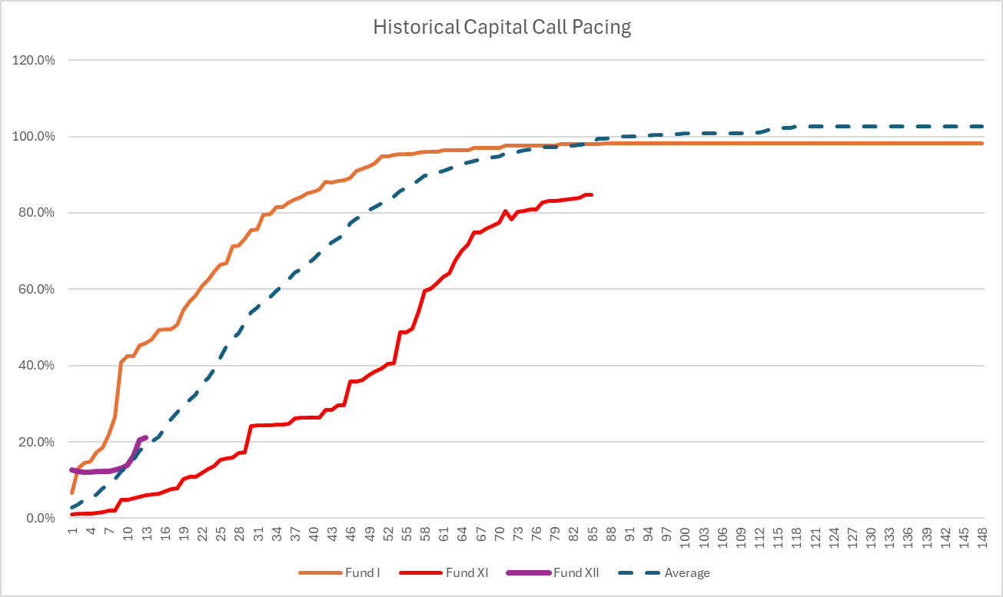
      - Interestingly, the quickest fund EnCap called was their first fund in 1994 and the slowest was their most recent fund (Fund XI, 2017). A significant percentage of Fund XII was called out of the gate, but the percentage called has fallen right back to the long-term average of roughly 20% at the 12–14-month mark. We are estimating that 25% will be called at closing. If the fund continues to track inline with history, we would project the following call schedule:
        - 9/30/24: 25%
        - 12/31/24: 5-7%
        - 3/31/25: 5-7%
        - 6/30/25: 6-8%
        - 9/30/25: 8-10%
        - 12/30/25: 5-7%
        - 2026: 17-20%
        - 2027: 13-17%
        - 2028: 0-15%

  - Distribution history (7/10, it varies a lot):
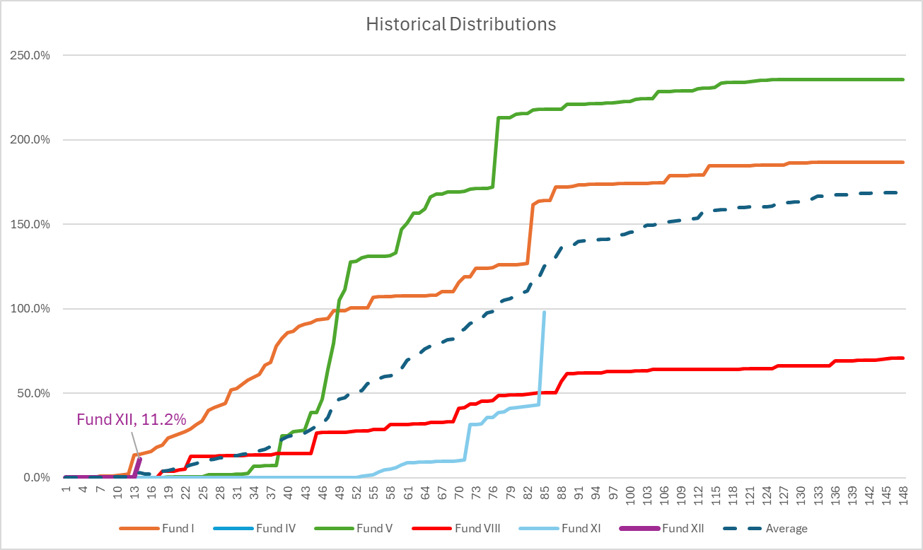
      - Predicting distributions is predicting returns, which is “variable” to say the least. We will note however, that EnCap is projecting a roughly 11.2% distribution sometime in the balance of 2024 following the Grayson Mill sale. This is very quick for them, but not unprecedented. Funds I, II, and VIII all had >10% distributions in the first two years. The VERY wide range of projected distributions would be the following:
        - 2025: 0%-29% (7.8% average)
        - 2026: 0%-35% (8.4% average)
        - 2027: 0%-72% (26.7% average)
        - 2028: 2%-67% (21.1% average)
        - 2029: 9%-68% (26.8% average)
        - 2030: 0%-69% (26.7% average)
        - 2031: 2.0%-32.7% (23.0% average)
        - 2032: 1.4%-49.7% (10.6% average)
        - 2033: 0%-17.7% (8.0% average)
        - 2034: 0%-27% (4.9% average)
        - 2035: 0-15.0% (3.8% average)

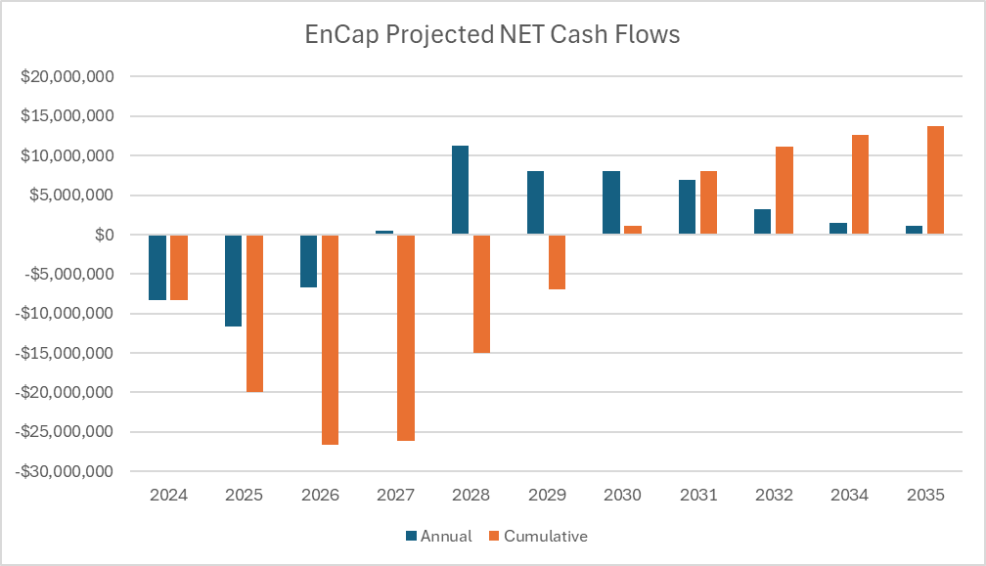
      - If this fund tracks the average (please see above for how wide the range could be), we could project a net out of pocket of about $27mm by the end of year two on a $37.5mm allocation, cash flow positive by year 3, and to have our basis back by year 6-7. This is a hypothetical example, not for actual cash planning.
  - Predictability of exit (8/10):
    - This will vary and is hard to handicap. Our thesis is that the robust M&A market will continue, and the sector will re-rate upwards. Corporates within the energy sector have dramatically underinvested in traditional oil and gas, which should bode well for further exits for private equity.
  - Investment period:
    - The investment period is the earlier of 5 years from the final closing date or when 75% of commitments have been invested or committed. The total term of the fund is 10 years with two one-year extensions if necessary.
  - Recycling/capital efficiency (9/10):
    - On average, EnCap Upstream funds have called roughly 41% of capital, net of distributions. The range has been between 34% (Fund IV) and 74% (Fund V). EnCap can recycle up to 50% of aggregate commitments within the investment period.
  - Projected final close:
    - September 30th, 2024

Quality: (9 out of 10)
  - Performance history (9/10):
    - Strong, as noted above.
  - Current team (9/10):
    - Described above. The partners have between 20-30 years’ experience and the investment team has 10-30 years’ experience.
  - Service providers (9/10): Vinson & Elkins (legal) and PricewaterhouseCoopers (audit). Banking with JP Morgan, Bank of Oklahoma, and Wells Fargo.
  - Stability of sponsor/management team (9/10): They have weathered a difficult period in the energy markets, have raised balance sheet capital by selling an estimated 25% of the EnCap management company to Dyal Capital, and have transitioned from the first to second generation of leadership.
  - Expected transparency (9/10): They give detailed quarterly reports, and we have good connectivity and relationships with key team members.
  - Background checks: [TBD]
  - Reference checks (10/10): Not needed. Team is well known.
  - Management fees (10/10, lower than standard PE fees):
    - Investors can choose between (Option 1) 2% of invested capital during the investment period and 1.5% of invested capital outside the investment period OR (Option 2) 1.5% of their committed capital during the investment period and 1.5% of invested capital outside of the investment period.
    - EnCap would have to call essentially all the capital in the next year and make no distributions for three years before option 2 would make sense.
  - Carried interest (standard): 20% with a full catch up.
  - Preferred return (standard): 8%
  - Additional expenses (9/10): No explicit cap, but below 5bps in every financial statement sampled.
  - Consistency of team (8/10): In July 2020 EnCap reduced the size of its Upstream investment team, including two partners and five members of the investment staff that were based in Dallas (closed the office). It is believed that the key members of the team were retained.
  - Valuation (8/10): They have a detailed valuation policy (in PPM), but they do self-mark their portfolio, which is common but not ideal. Year-end valuations are audited by PricewaterhouseCoopers.

Risk/Reward: (10 out of 10)
  - From EnCap’s 2023 Annual Meeting:
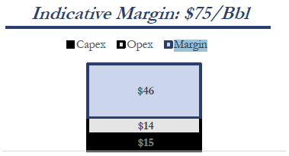
    - This is a VERY simple model, but a good generalization.
    - It is also just a proxy for fund level returns, as this model is just projecting an individual investment that funds 100% upfront. Do not compare the MOIC of this model to the historical performance of EnCap funds (higher capital efficiency, so higher IRR relative to MOIC).
    - So, based on EnCap’s assumptions, a barrel of oil is yielding roughly 60% margins at $75.
    - According to both EnCap and Quantum, private E&P companies are trading at 2.8x cash flow.
    - Assume that the average holding period for an EnCap fund is around 8 years (historically distributions rise until year 7-8 and level off)
  - Upside case (10/10): Assume no improvement in costs from productivity (or increased cost inflation), assume multiples go back to pre-COVID levels (4.5x vs. 2.8x), and assume oil prices average $76/bbl (the 75th percentile over the past 20 years).
    - The NET IRR from this simple model is 28.9% and the MOIC is 7.6x.
  - Base case (10/10): Assume no improvement in costs from productivity (or increased cost inflation), assume multiples stay the same (2.8x), and assume oil prices average $64/bbl (the 50th percentile over the past 20 years).
    - The NET IRR is 18.4% and the MOIC is 3.9x.
  - Worst case (20/10, that’s a joke): Assume no improvement in costs from productivity (or increased cost inflation), assume multiples stay the same (2.8x), and assume oil prices average $45/bbl (the 10th percentile over the past 20 years).
    - The NET IRR is 1.1% and the MOIC is 1.09x. (Oil would need to average $40/bbl to lose money).
  - Leverage (10/10): Average leverage across the portfolio companies is under 1x debt/EBITDA, which is consistent with history. Capital call subscription lines of credit, which are typical for private equity funds, can be used for administrative ease of bridging capital calls.
  - Concentration (8/10): Probably will end up more concentrated than historically, and is only U.S.
  - GP Commitment (7/10): The GP commitment is projected to be roughly 4.7% ($188mm). Despite the large dollar amount, I would like to see this higher considering the GP’s ownership in Fund XI is currently $1.7b.
  - Risks and mitigants (9/10):
    - Risk: Energy price declines due to structural issues (energy transition) or recession.
      - Mitigant: A sensitivity analysis to energy prices was presented earlier in this section. We believe that there is a structural underinvestment in traditional energy that will mitigate short term demand shocks. We believe the timing of the long-term decrease in demand is being significantly overstated.
    - Risk: Execution risk, as EnCap could pick bad operators.
      - Mitigant: EnCap has backed several hundred companies over the past 30 years and has a very high hit rate.
    - Risk: Supply only appears tight due to structural understatement of shale reserves.
      - Mitigant: Valuations compression (down 40-50%) mitigates this risk. What is not understated is the tight conditions in the number of rigs operating or DUCs.
    - Risk: Regulatory Risk – Potential future regulations limiting emissions, restrictions on fracking, new incentives for electric vehicles or renewable energy production, and other limitations on land use.
      - Mitigant: The move toward cleaner energy has been a multi-year process, and many of the new techniques have been integrated into EnCap portfolio companies (water recycling, leak detection, etc.). Further developments in energy transition present both challenges (which they have already been adapting to) and opportunities, that they can benefit from across EnCap portfolios.
  - Risk/reward (10/10): Our base case is an IRR of 18.4%, resulting in a MOIC of 3.9x under our analysis. A comfortable downside of 1.09x (1.1% IRR) results in a reward/risk payoff of 15x.

WHY: (10 out of 10)
  - Theme (10/10): See Energy Theme chartbook. We believe the following:
    - Demographics: Continued population growth in Asia and other emerging economies will continue to drive demand for fossil fuels for the foreseeable future.
    - Growth of AI/compute: Rapid growth in compute speed, driven by widescale AI adoption, will drive a significant increase in demand for datacenters, hence energy. It is unlikely that renewables will be able to meet this need in the near-term.
    - Energy transition: The estimates for how quickly the energy transition will occur are extremely aggressive and unrealistic. Barring multiple significant technological advancements in the very near-term, at current valuations traditional energy investors are being compensated to bear this risk.
    - Underinvestment: After the pullbacks in energy markets after the shale revolution (2015-2016), followed by another round of energy market pain due to COVID, most companies across the energy industry adopted a posture much more focused on financial discipline. Leverage has come down and CAPEX have come down, while dividends and share buybacks have increased.
    - Lack of institutional capital: Much like energy companies, institutional investors have retrenched from allocating to energy markets. This is seen in public markets, as IPOs and secondary sales have all but stopped, and in private markets as most energy PE firms have ceased raising new funds. Firms that are able to raise PE energy funds have seen sizes decrease 20-50%.
    - Valuation: The energy industry has seen valuations decline 40-60% in just the past 5 years. Private market valuations are at EXTREMELY attractive levels.
    - Tight supply: The net result of the last three points is that storage is 50% what it was 10 years ago, rig counts continue to trend downwards, and wells drilled but not completed are as low as they’ve been since that metric has been tracked.
    - Profitability: Energy companies are experiencing near all-time high valuations, while efficiency (EBITDA/employee) is continuing to make new all-time highs.
  - What will be the most important factor for success?
    - The most important factor is that the energy transition doesn’t happen in the next three years. It is also important that EnCap continues its strategy of buying cheap, accelerating with growth capital, and selling slightly less cheap.
  - Projected co-investment ratio (9/10): $1:1 (potential for deal flow outside the fund, good relationship with the firm)
  - Tech forward company/sponsor? (7/10)
    - Not as much as we would like.
  - Expands our network? (9/10)
    - Yes. If we want to invest in energy in the United States, EnCap is the most respected team.
  - Additional terms negotiated (8/10):
    - Co-invest at 1:1, direct personal investment accepted. This is not contractual, but a handshake agreement.

